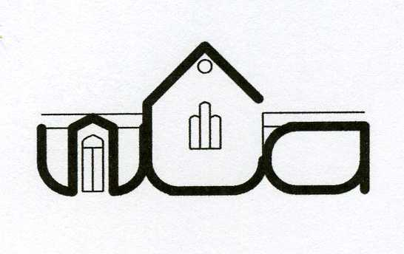
Wingrave Community Association

Minutes of the council meeting held on Tuesday 17th June 2014 at 8pm in the Community Centre

Present: Neil Laming (Chairman); John Hawkes (Treasurer); Louise Wyles (Secretary); Tony Lambourne; Lydia Giggle; Sylvia Francis; Tony Horne; Siv Tunnicliffe; Chris Harrison; Alan Frost; Geoff Aldridge; Amy Cleaver; Sylvia Francis

Apologies: Hilary Aldridge; Janet Frost; Lynne Roxbee Cox; Martin Cowling; David Harnett; Norman Rickard

- The minutes of the council meeting held on 29 April 2014 were approved.

- Chairman’s report
  - Given during AGM
  - For the remainder of 2014 looking to create a PR sub-committee made up of new people on the council with the objective of publicising the WCA and the great work undertaken

- Treasurers report
  - Treasurer took the meeting through the figures for the financial year which are in line with expectations.

- Group reports
  - Bar report:
    - Credit card facility set up from 1 April. £214 taken during 1st BBQ
    - During April bar meeting drinks profitability was reviewed and a decision taken in light of prudent buying and reduced wastage to hold prices for this year
    - Outlook for social events is positive with more booked through summer than last year
  - Music in quiet places
    - Concert took take place in parish church on Saturday 14th June at 7.30pm.
  - Church
    - Church will be running of the BBQs and are pleased to be getting involved in local activities
    - A new team vicar has been appointed Helen Barnes. She will start 8 July and be licensed for Wing and Wingrave. It is hoped that Helen will be attending future WCA meetings and the village BBQ.
  - Wingrave Singers
    - Enjoy use of the hall after rehearsals
    - In Nov will be singing the services and in Feb next year there will be a Valentines concert
  - Theatre in village
    - Sunday 12 Oct at 7pm booked for “Movies and Musicals” – hall will be set up in cabaret style with 9 round tables
  - Wingrave Players
    - Saturday 6th Dec – Christmas Showtime
  - Bell Ringers
    - 29 June the bell tower will be opened for people wishing to take advantage of the views
    - Several recent occasions to fly the flag above the church
  - Playgroup
    - New group for young children of the village and their mums/ childminders to meet and play
    - Started in Jan. Really well attended with average of 20 families per week
    - Group are grateful for £500 grant from WCA to be used for toys etc for the children
    - Storage space for toys is an issue – meeting approved a reasonable spend to erect a shed for use by the WCA and the playgroup for storage.
  - Baby sensory
    - Baby sensory classes to start in September on a Thursday at the hall between 9 and 1
  - Coffee Shop
    - There will be a trial of a coffee shop open to all for a drink and cake on Thursdays.

- AOB
  - Maintenance
    - Ducting in the loft needs replacing. Council approved the spend to update ducting and the boiler controls including ability to zone parts of hall to heat separate areas. Target to have this completed by September
    - Recommendation to look at replacing the boiler in couple of years
    - Group found who are offering manpower FOC to do jobs at the community centre – WCA need to provide materials. They will be carrying out 11 projects over the next couple of months
    - Sound system needs updating
    - Discussion around use of the rec during the village BBQs. Neil and Tony to meet relevant people to discuss the continuation of this
  - Membership Secretary
    - Martin Cowling is standing down as membership secretary
    - No one at the meeting agreed to take on this role.
    - Lou to put request on epostie and in communique
    - Martin to be asked if he can scope out the volunteers who carry out each round to see if anyone would be interested in taking on the role.
    - £3k is at risk if someone doesn’t take on this role
    - Siv will ask in church on Sunday.

Date of next meeting: 2nd September

Louise Wyles
Secretary
lou@cweventproductions.com

