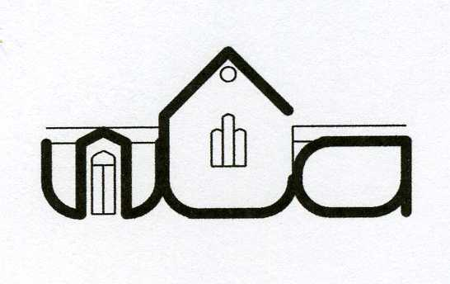
Wingrave Community Association

Minutes of the AGM held on Tuesday 12th June 2018 at 8pm in the Community Centre

Present: Neil Laming (Chairman); Andy Targell (Treasurer); Louise Wyles (Secretary); Lynne Roxbee Cox; Lydia Giggle; John Hawkes; Tony Horne; Chris Harrison; Lynne Crump

Apologies: Alan Frost; Janet Frost; Norman Rickard; Patrick Roxbee Cox; Tony Lambourne; Suzanne Cuthbert; Brenda Horne

- The minutes of the AGM held on Tuesday 13 June 2017 were approved

- There were no matters arising

- Chairman’s report
  - Thank you expressed to the council for all the work carried out to help Neil whilst he’s been chair – particular thanks to Andy, Tony, Lou, Lynne and Lydia.
  - Phases 1 and 2 of Vision 2020 has been completed
  - Neil will stay on the committee to project manage the hall renovations
  - Neil is very proud of the improvements that have been carried out and has enjoyed his time as chair
  - Neil has offered any help required in the future
  - Thanks expressed to Neil for all of his work as chair

- Treasurer’s report
  - Treasurer took the meeting through the financial statements for the year ended 31st March 2019 which were proposed, approved and adopted for the year.
  - The chairman signed the accounts
  - Expenses were high with money taken from the major repairs fund for the bar renovations
  - Income was good considering the time the hall was shut for the renovations
  - Council agreed the finances are in line with expectations and there was no cause for concern.
  - Thanks expressed to Andy for his work

- Election of Officers
  - Neil Laming stood down as chairman and Andy Targell was elected chairman
  - Louise Wyles re-elected unopposed as secretary
  - Andy Targell stood down as treasurer and Lyn Crump was elected unopposed as treasurer

- Election of council
  - All present members, and those who sent their apologies, were elected to the council in addition to the property trustees.

- Appointment of Independent Examiner
  - Pheroza Bulsara has agreed to continue as independent examiner for another year and was unanimously elected.

- Any Other Business

There being no other business the meeting closed

Andrew Targell Chairman

Lynne Crump Treasurer

Louise Wyles Secretary

Date of next AGM: to be agreed

Louise Wyles
Secretary
secretary@wingrave-wca.co.uk

